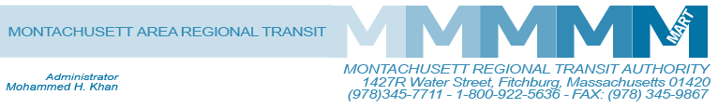

Posted 04/10/2014 at 2:29 pm by JAV

MEETING OF THE MART Finance/Executive Compensation COmmittee
MART Maintenance Facility
1427R Water Street
Fitchburg, MA 01420

Tuesday, April 15, 2014
10:00 A.M.

Agenda

- Approval of February 6, 2014 minutes
- Approval of March 11, 2014 minutes
- FY 14 Budget Update
- FY 15 Budget Request Review
- HST Contract Status
- IG Investigation update
- CTS Transition to MART from CTAA
- MTS letter
- State Retirement Board Ruling/Actuarial update
- Compensation Plan
- Review Minutes Structure
Adjournment
C: City and Town Clerks: Please post this notice pursuant to MA General Laws Chapter 30A,
Sections 18-25.

